

**MIDDLE EAST TECHNICAL UNIVERSITY**

**DEPARTMENT OF ELECTRICAL & ELECTRONICS ENGINEERING**

**E463 – PROJECT #2**

**İven Güzel (2030831)**

**Etki Açılan (2165694)**

**16.12.2018**

**TABLE OF CONTENTS**

INTRODUCTION

QUESTIONS

# Single Phase Controlled Rectifiers

1. Calculation of the required firing angle α and verification

Fully controlled topology:

$$Vavg= \int_{α+u}^{π+α}{\frac{\sqrt{2} Vs sinwt dwt}{π} }$$

$$=\frac{\sqrt{2} Vs[cos\left(α+u\right)-cos⁡(π+α)]}{π}$$

$$= \frac{\sqrt{2} Vs[cos\left(α+u\right)+cos⁡(α)]}{π}$$

$Vcom= \int_{α}^{α+u }{\frac{\sqrt{2} Vs sinwt dwt}{π}}=wLs \int_{Idmin}^{Idmax}{did}$

$$\frac{\sqrt{2} Vs[cos\left(α\right)-cos⁡(u+α)]}{π}= wLs*40$$

$$\cos\left(u+α\right)=\cos\left(α\right)- \frac{40π*wLs}{\sqrt{2} Vs}$$

Put this equation into Aavg,

$$Vout,avg= \frac{2\sqrt{2} Vs cos⁡(α)}{π}-40*wLs$$

$$\frac{Vout,avg}{Rload}=Iout,avg=40A =\frac{207.92*\cos\left(α\right)-6.28}{4}$$

$$α=36.89°$$

Half controlled topology:

Similar to the first calculation,

$$Iavg*R=Vavg=160V$$

$$0.9Vs*\cos\left(α\right)-wLs*Iavg=160V$$

$$α=56.55°$$

Simulation result of fully controlled topology,

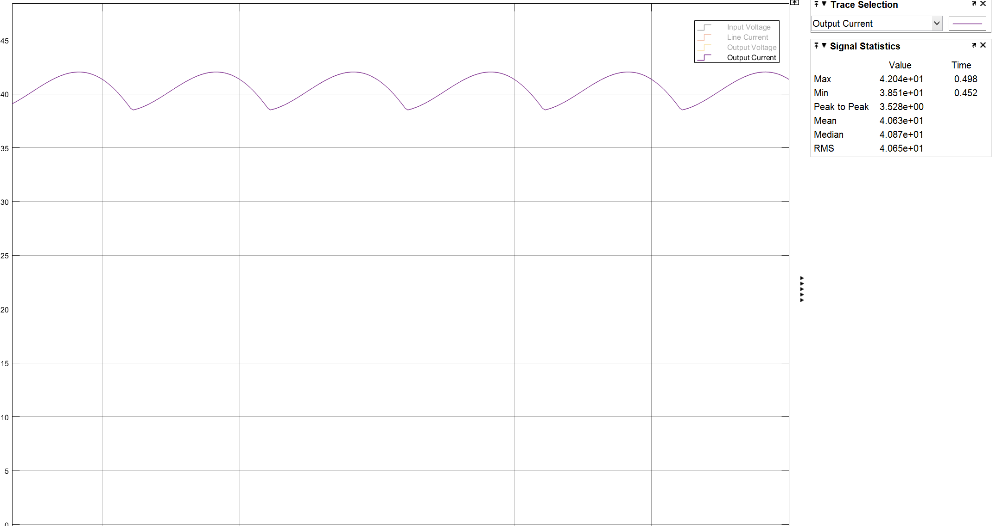

Şekil 1 Output Current Simulation Result of Fully Controlled Topology

As can be seen from Figure 1 and the calculations for fully controlled topology, they are consistent. The simulated results is 40.6A and the required value was A. The little amount of discrepancy is a result of rounding on the calculator and unbalance on the oscilloscope screen in Figure 1.

Simulation result of half controlled topology,

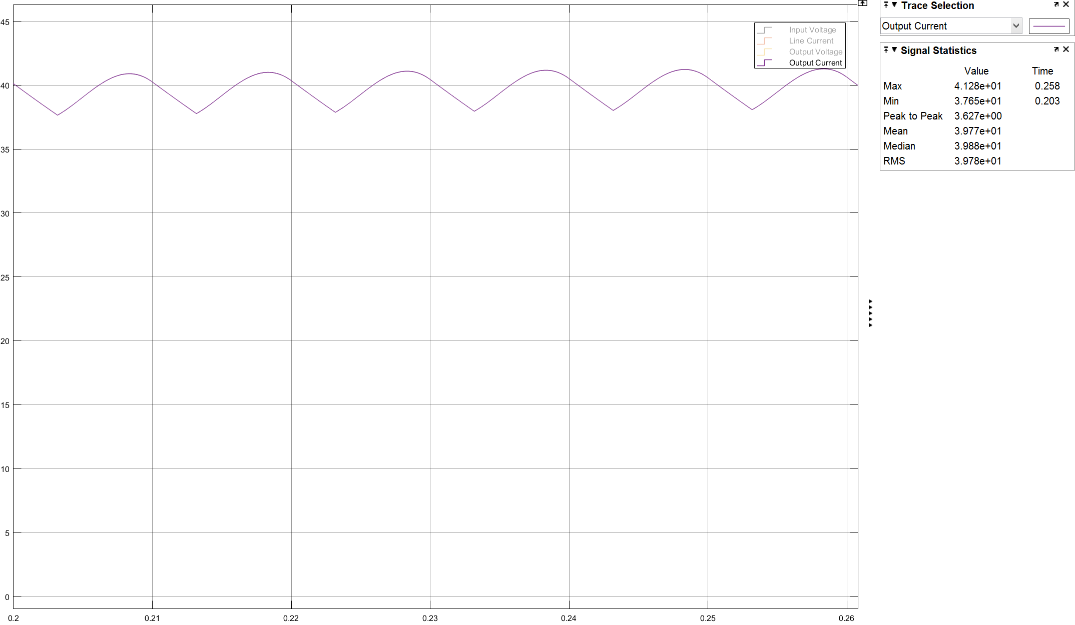

Şekil 2 Output Current Simulation Result of Half Controlled Topology

As it can be seen from Figure 2 and the calculations of half controlled topology, they are also consistent with each other. The simulation result was 39.77A where the required value was 40A. The little discrepancy is because of the same reason.

1. Graphical results of Vs and Is and THD values of Is

Figure 3 shows the input current and voltage of fully controlled topology

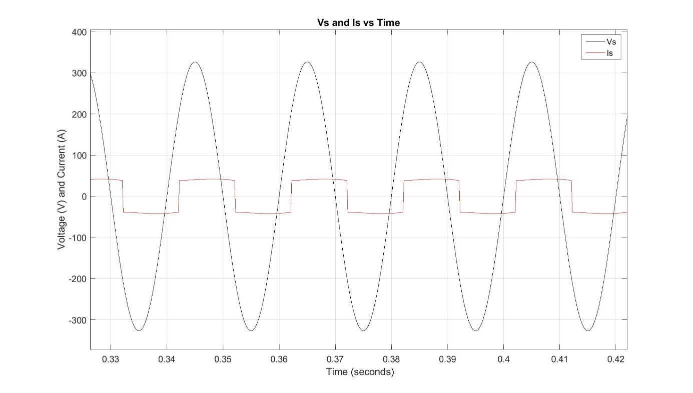

Şekil 3 Vs and Is vs Time of Fully Controlled Topology

Figure 4 shows the input current and voltage of half controlled topology.

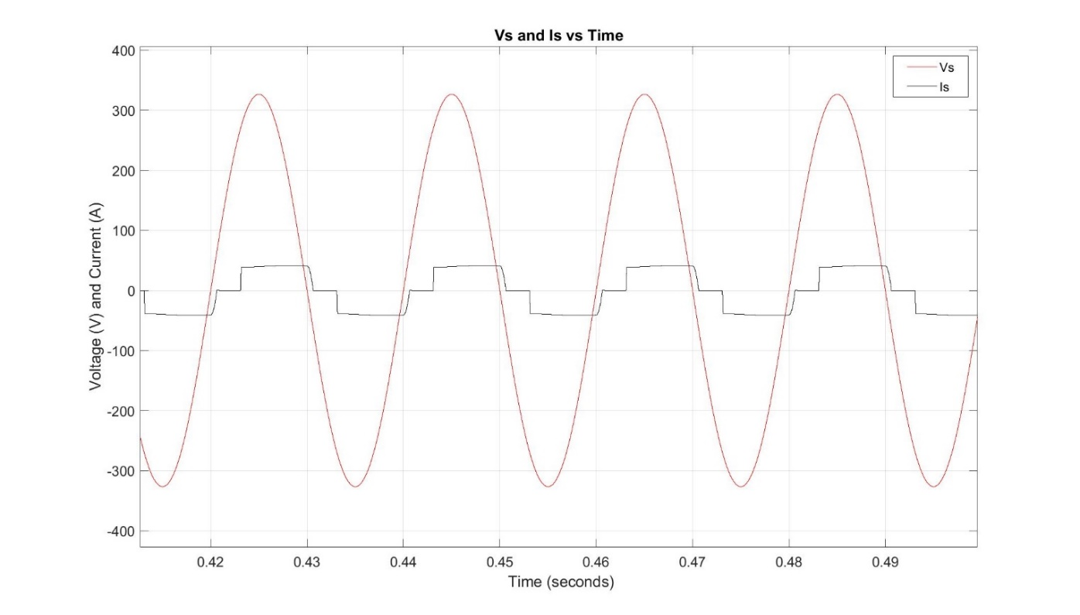

Şekil 4 Vs and Is vs Time of Half Controlled Topology

Figure 5 shows the THD of input current for fully controlled topology,

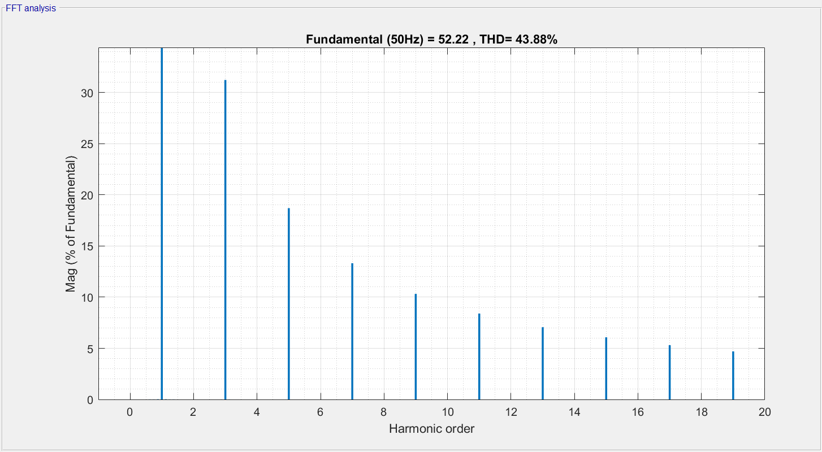

Şekil 5 THD of Is for Fully Controlled Topology

Figure 6 shows the THD of input current for half controlled topology,

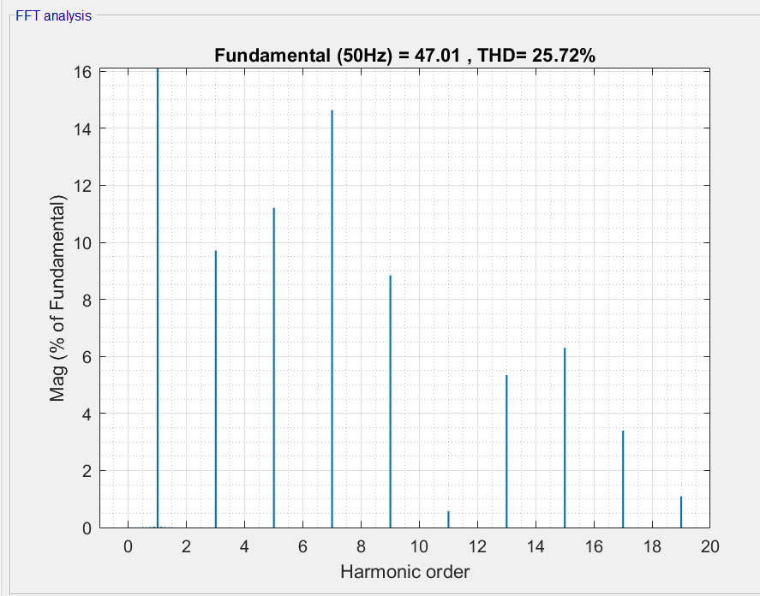

Şekil 6 THD of Is for Half Controlled Topology

1. Comparison of the Topologies

The fully controlled topology allows unidirectional power flow. By means of this, it can operate as a rectifier and an inverter. The output voltage can be negative. It has two more thyristors instead of two diodes as in the case of half controlled topology. This results more complex and expensive gate drive circuitry. It can be used any industrial application where utilization of the inverter mode operation is important. However, they have worse input power quality than half controlled topology. The half controlled topology is also called unidirectional converter because of the fact that the voltage cannot be negative. This results that we only have control in the half of the wave. Also, since the voltage cannot be negative, the power flow is permitted only from AC to DC side. It cannot operate at inverter region. While the output is zero at negative cycle, the load current drawn is also zero. This results a more sinusoidal form than the fully controlled topology for input current and less THD. Its application areas include where inverter operation is unnecessary or not desirable.